**Robert Mc Namara | K00118447**

Internet systems development – ISD4

**Restaurant Finder**

**Google Play Store Description:**

Restaurant Finder offers a convenient way to find restaurants around a location. You can search for a restaurant by name and by type, or else you can look through a simple list of restaurants where you can see their type and their distance from your current location. This interactive app allows you, the user to view details about a restaurant; all the regular stuff like addresses and contact details, but here is the difference, Restaurant Finder allows you to view their menus and any offer/deal the restaurant might have available. There is also a section where you can view a list of these offers/deals being run by restaurants and it also calculates the distance between you and them.

Restaurant Finder is aimed at providing the best, most up-to-date information, this information is provided by the restaurants themselves. This generates a new level of competition between the restaurants giving you additional benefits of cheaper prices and more selection.

This app uses modern intuitive swipe navigation while also retaining tabbed navigation for both new and old users of Android.

If you are looking for food, this app will find it for you. You don't even need to type anything!

**Key Features:**

Customer side:

* View all restaurants and deals in the area
  + All data is stored online. Data is downloaded from the online database when necessary using a web service. If data is added, it becomes available immediately, by reloading the current activity.
* Save favorite restaurants for future use
  + Saves restaurant you like locally, using the devices built in storage. This feature helps to organize your eating out habits, by having your favorite places to eat all available in one place.
* Search for a restaurant by name and type
  + Searches the online data based on your criteria
* Get directions to a restaurant
  + If you don’t not know the area! Or are unsure of where a restaurant is. You can Restaurant Finder to get directions from your current location right to the door of the restaurant.
* Calculates the distance between you and your meal!!
  + Based on your current location, works out how far you have to go. Useful when comparing potential diner options

Business side:

* Add a restaurant (includes edit and delete)
  + This is the app connecting to the web service and reading or writing data. This is how restaurants get into the system and how the data stays up to date.
* Add offers/deals (edit and delete)
  + Similar to above, this is how offers and deals get published and how they say up to date. This feature like I discussed before creates a sense of competition between restaurants.

**App Screenshots:**

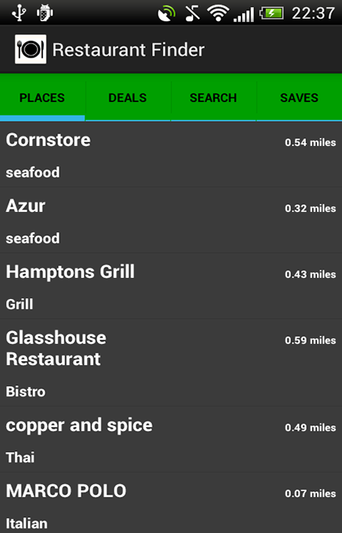

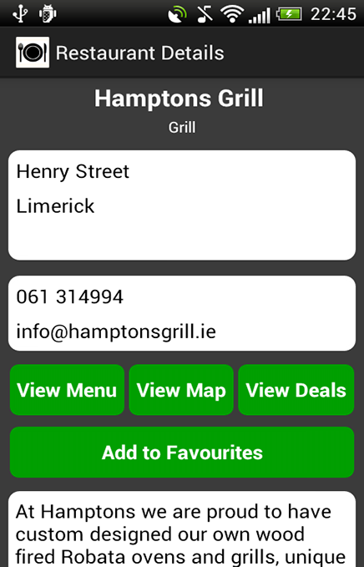

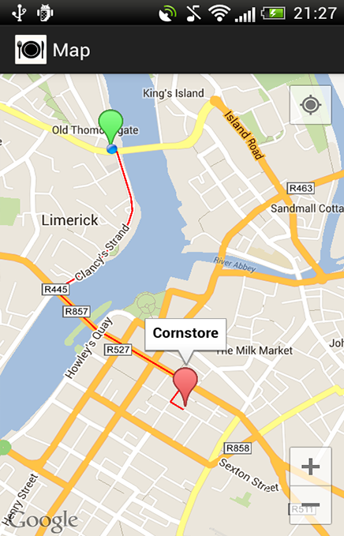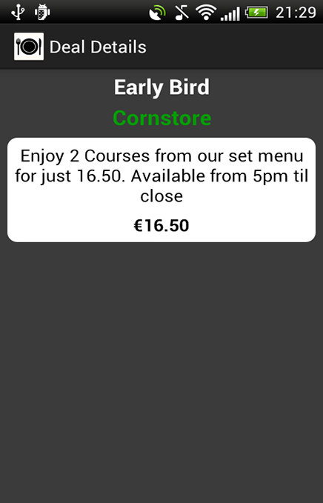

**Permissions:**

Your Location:

* Approximate location (network-based)

Allows the app to get your approximate location. This location is derived by location services using network location sources such as cell towers and Wi-Fi. These location services must be turned on and available to your device for the app to use them. Apps may use this to determine approximately where you are.

* Precise Location (GPS and Network-Based):

Allows the app to get your precise location using the Global Positioning System (GPS) or network location sources such as mobile towers and Wi-Fi. These location services must be turned on and available to your device for the app to use them. Apps may use this to determine where you are, and may consume additional battery power.

Internet:

* Network Communication

Allows the app to create network sockets and use custom network protocols. The browser and other applications provide means to send data to the Internet, so this permission is not required to send data to the Internet. Also allow the application to access the information about the networks.

Storage:

* Modify or delete the contents of your USB storage.
* Modify or delete the contents of your SD card.
* Allows the app to write to the USB storage.
* Allows the app to write to the SD card.

**Future Work / Enhancement:**

This app is currently on beta version 2.0, but there is plenty scope for current improvements and future work. This further work can be broken into two sections, one how to improve the beta version and two the commercial development of this app.

First there are numerous improvements I would like to implement before version 3.0, as the app grows and more restaurants get added. The list views in the app need to be modified and improved to include a ‘load more’ button, this will considerably improve the user experience of the app. Also the search feature needs to be refined, at the minute it needs both criteria to perform a search (restaurant name and type), I would like to improve this feature, so it only needs one piece of information to perform the search. Finally in this section I will improve the ‘saves’ section to allow the user to add deals as well as restaurants to local storage.

Next I will discuss the scope for future work and the commercial development of the application. Again as the app grows it will be possible to generate more revenue from the application. This will involve splitting the app into two apps, one for the customer looking for restaurants and deals, and the other app is for the restaurant owner who wants to add and maintain their restaurant/s. This is how the app will generate money, by charging the restaurants a small subscription to get listed. Another aspect to this is, once the restaurants are paying to be listed, it will be possible to incorporate a digital voucher system, where a customer will receive a discount or special offer, for presenting their app at a participating outlet, this will encourage potential customers to use the app. All the time the app aims to create competition between the different restaurants. Another worthwhile development will be localization of the app/s to include more languages attracting the largest potential audience.